**MODULE 4 : (103109)**

**Q.1.**

* CREATE A TABLE BASED WITH TABLE NAME “XXCUSTLAB01USER09” WITH CORRESPONDING COLUMNS AS SHOWN BELOW.

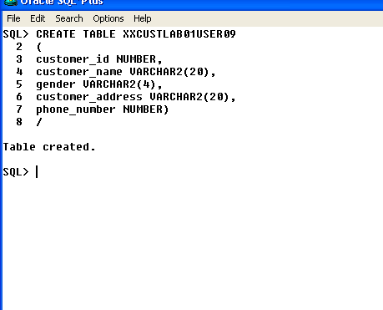

* CREATE A CONTROL FILE FOR LOADING DATA INTO THE TABLE AS SHOWN BELOW.
* USE POSITION USE ALIGNMENT FOR ENTERING THE DATA.
* **IF GENDER IS “M” AND “F” THEN ONLY DATA HAVE TO ENTER IN THE TABLE ORELSE ERROR OUT.**
* **NAME OF CONTROL FILE IS “XXCUSTLAB01USER09.CTL”**

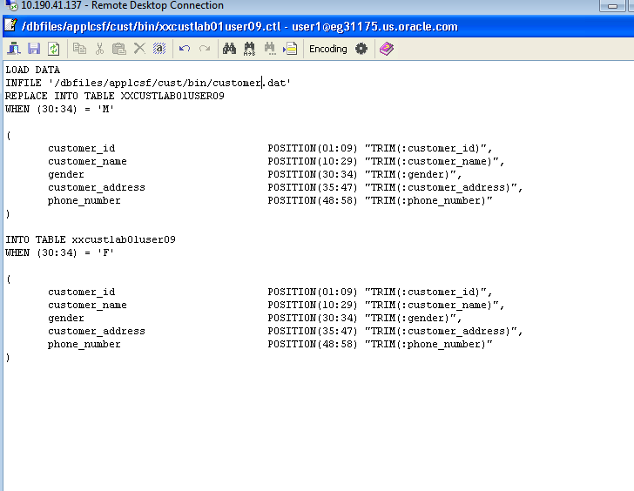

* DATA FILE FOR CONTROL FILE WHICH WILL UPLOAD THE DATA INTO THE TABLE BASED ON THE POSITION ALIGNMENT AND CONDITIONS APPLIED.

**DATA FILE NAME IS “CUSTOMER.DAT”**

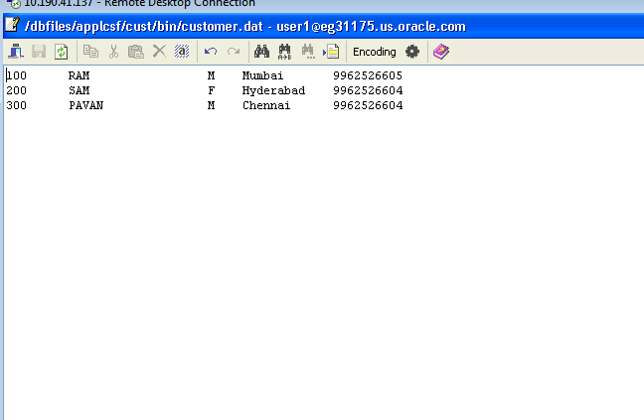

* AFTER CREATING THE CONTROL FILE AND DATA FILE,
* GO TO ORACLE APPLICATION AND IN THE CUSTOM RESPONSIBILITY, CREATE A” EXECUTABLE METHOD” FOR CONTROL FILE WITH “SQLLOADER METHOD”

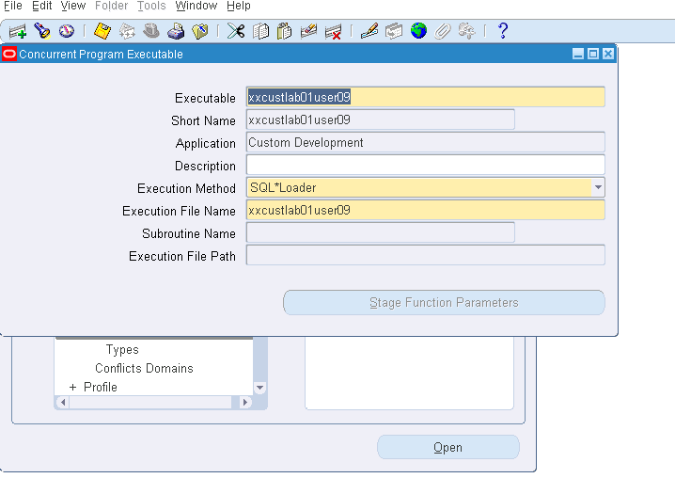

* CREATE A CONCURRENT PROGRAM “CUSTOM SQLLOADER PROGRAM 09” WITH THE CREATED EXECUTABLE METHOD(SQLLOADER METHOD) AS SHOWN BELOW.

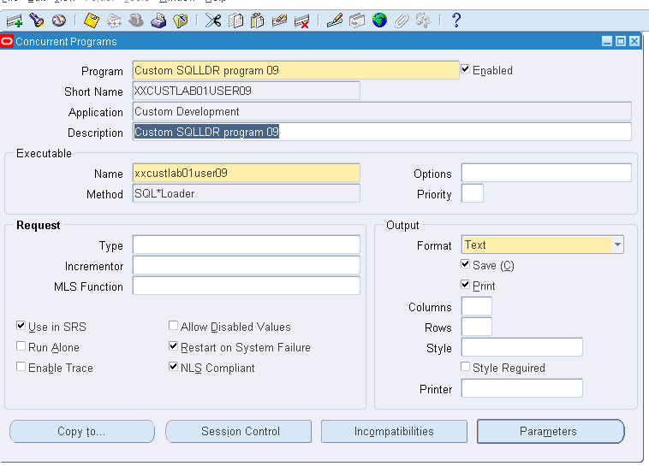

* AFTER CREATING THE CONCURRENT PROGRAM, REQUEST THE PROGRAM IN THE SUBMIT THE REQUEST FOR CONCURRENT PROGRAM.
* AFTER SUCCESSFULLY COMPLETION OF THE REQUEST ,THE DATA IS ENTERED IN THE TABLE AS SHOWN BELOW.

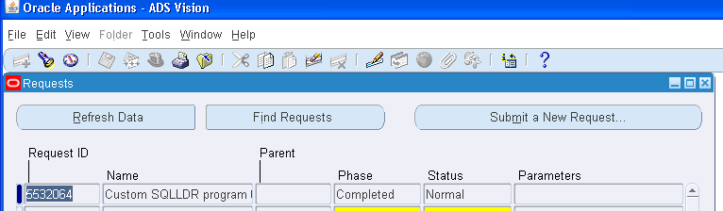

* HERE THE TABLE IS INSERTED WITH THE DATA GIVEN IN DATA FILE THROUGH CONTROL FILE AS SHOWN BELOW:

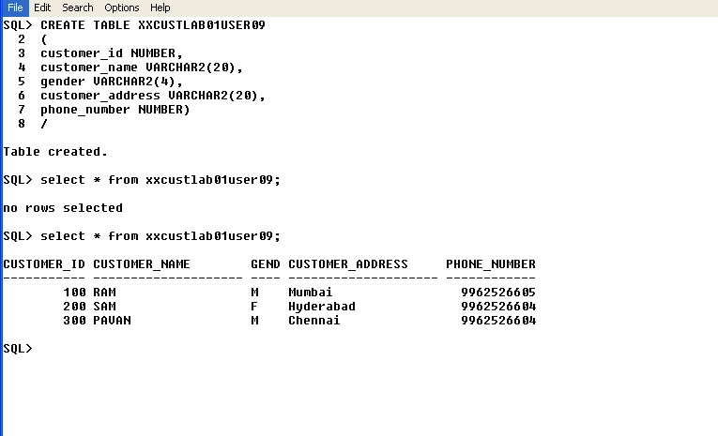

*************************************************************************************************************************************************************************

**Q.2**

* Create a new table “**XXCUSTLABSTGUSER09**” WITH THE FOLLOWING COLUMNS AS SHOWN IN THE BELOW FIGURE

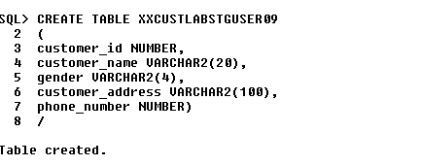

CREATE A PACKAGE WHICH WILL VALIDATE THE FOLLOWI NG TWO RULES:

* **1. IF MOBILE NUMBER IS GREATER THAN 10,THEN REJECT THE ROW TO ENTER IN THE NEW TABLE CREATED.**

FUNCTION validate_mobile_number(p_customer_id XXCUSTLAB01USER09.customer_id%TYPE) RETURN CHAR

IS

v_mobile_number NUMBER;

BEGIN

-- FIRST VALIDATE THE PHONE NUMBER BY COUNTING THE LENGTH --

SELECT LENGTH(phone_number)

INTO v_mobile_number

FROM XXCUSTLAB01USER09

WHERE customer_id = p_customer_id;

IF v_mobile_number > 10 THEN

RETURN 'E';

END IF;

RETURN 'P';

END validate_mobile_number;

* **2.THE GENDER SHOULD BE DISPLAYED AS “MALE” FOR “M” AND**

**“FEMALE” FOR “F”.**

FUNCTION gender_value(p_customer_id XXCUSTLAB01USER09.customer_id%TYPE) RETURN VARCHAR2

IS

v_gender VARCHAR2(15);

BEGIN

-- SECOND VALIDATAION IS TO CONVERT THE GENDER CHARACTERS TO "MALE" AND "FEMALE" --

SELECT gender

INTO v_gender

FROM XXCUSTLAB01USER09

WHERE customer_id = p_customer_id;

IF v_gender = 'M' THEN

RETURN 'Male';

ELSIF v_gender = 'F' THEN

RETURN 'Female';

END IF;

END gender_value;

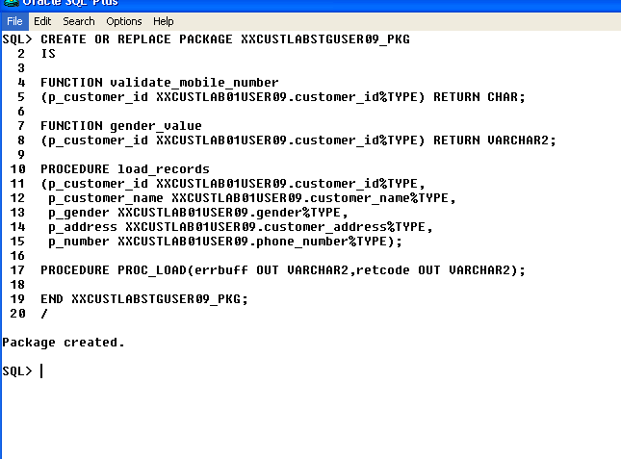

* NOW CREATE THE PACKAGE BODY ALONG WITH THE PROCEDURE AND FUCNTIONS AND EXECUTE IT.

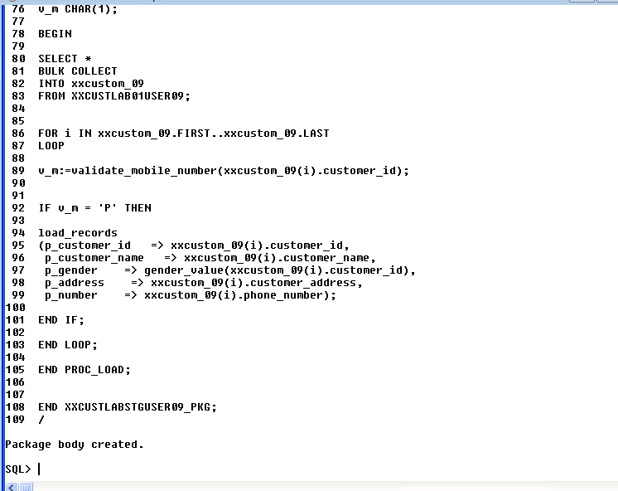

* PACKAGE BODY WITH FUNCTIONS AND PROCEDURE:

CREATE OR REPLACE PACKAGE BODY XXCUSTLABSTGUSER09_PKG

IS

FUNCTION validate_mobile_number(p_customer_id XXCUSTLAB01USER09.customer_id%TYPE) RETURN CHAR

IS

v_mobile_number NUMBER;

BEGIN

-- FIRST VALIDATE THE PHONE NUMBER BY COUNTING THE LENGTH –

SELECT LENGTH(phone_number)

INTO v_mobile_number

FROM XXCUSTLAB01USER09

WHERE customer_id = p_customer_id;

IF v_mobile_number > 10 THEN

RETURN 'E';

END IF;

RETURN 'P';

END validate_mobile_number;

FUNCTION gender_value(p_customer_id XXCUSTLAB01USER09.customer_id%TYPE) RETURN VARCHAR2

IS

v_gender VARCHAR2(15);

BEGIN

-- SECOND VALIDATAION IS TO CONVERT THE GENDER CHARACTERS TO "MALE" AND "FEMALE" --

SELECT gender

INTO v_gender

FROM XXCUSTLAB01USER09

WHERE customer_id = p_customer_id;

IF v_gender = 'M' THEN

RETURN 'Male';

ELSIF v_gender = 'F' THEN

RETURN 'Female';

END IF;

END gender_value;

PROCEDURE load_records

(p_customer_id XXCUSTLAB01USER09.customer_id%TYPE,

p_customer_name XXCUSTLAB01USER09.customer_name%TYPE,

p_gender XXCUSTLAB01USER09.gender%TYPE,

p_address XXCUSTLAB01USER09.customer_address%TYPE,

p_number XXCUSTLAB01USER09.phone_number%TYPE)

IS

BEGIN

INSERT INTO XXCUSTLABSTGUSER09

(customer_id,

customer_name,

gender,

customer_address,

phone_number)

VALUES

(p_customer_id,

p_customer_name,

p_gender,

p_address,

p_number);

END load_records;

PROCEDURE PROC_LOAD(errbuff OUT VARCHAR2,retcode OUT VARCHAR2)

IS

TYPE xxcustom09 IS TABLE OF XXCUSTLAB01USER09%ROWTYPE INDEX BY pls_integer;

xxcustom_09 xxcustom09;

v_g VARCHAR2(9);

v_m CHAR(1);

BEGIN

SELECT *

BULK COLLECT

INTO xxcustom_09

FROM XXCUSTLAB01USER09;

FOR i IN xxcustom_09.FIRST..xxcustom_09.LAST

LOOP

v_m:=validate_mobile_number(xxcustom_09(i).customer_id);

IF v_m = 'P' THEN

load_records

(p_customer_id => xxcustom_09(i).customer_id,

p_customer_name => xxcustom_09(i).customer_name,

p_gender => gender_value(xxcustom_09(i).customer_id),

p_address => xxcustom_09(i).customer_address,

p_number => xxcustom_09(i).phone_number);

END IF;

END LOOP;

END PROC_LOAD;

END XXCUSTLABSTGUSER09_PKG;

/

* AFTER CREATING THE PACKAGE, OPEN ORACLE APPLIACTION AND CREATE A EXECUTABLE METHOD OF PLSQL STORE PROCEDURE AS SHOWN BELOW.

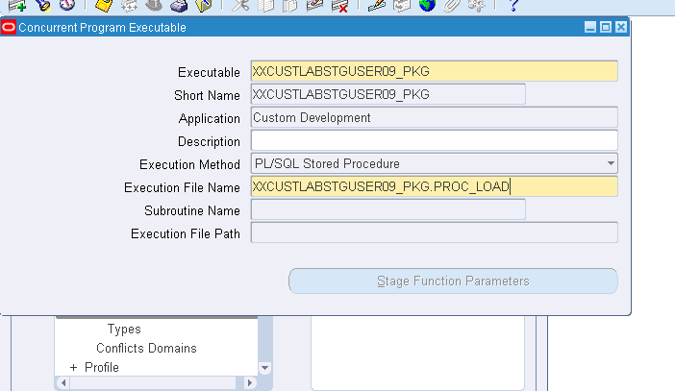

* USING THE EXECUTABLE METHOD, CREATE A CONCURRENT PROGRAM AS SHOWN BELOW.

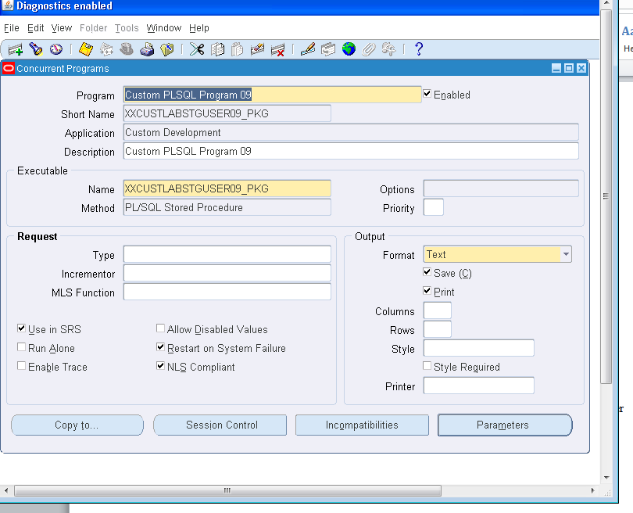

* RUN THE CONCURRENT PROGRAM BY SUBMITTING THE REQUEST IN THE REQUESTS.

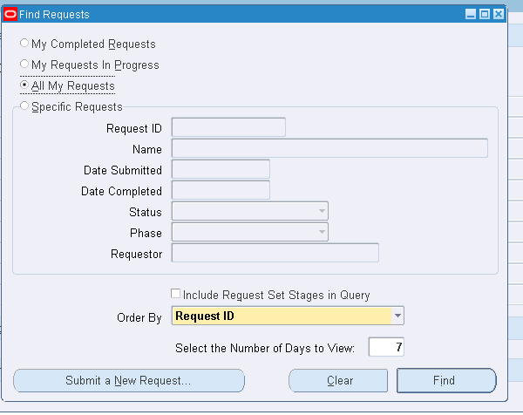

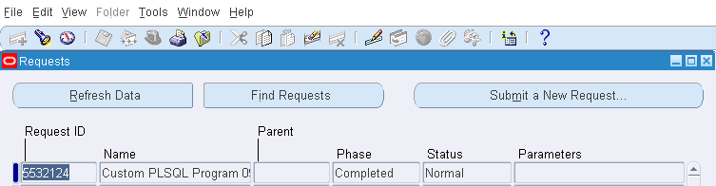

* AFTER SUCCESSFULLY COMPLETION OF REQUEST,THE NEW TABLE WILL GET THE VALUES THROUGH THE VALIDATIONS AS SHOWN BELOW.

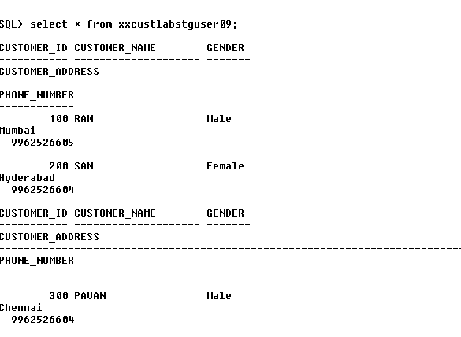

**Valiadation:**

* On giving 11 digit mobile number values to the “xxcustlab01user09”table,it is loaded in the table using SQLLOADER WE CREATED AS shown below.

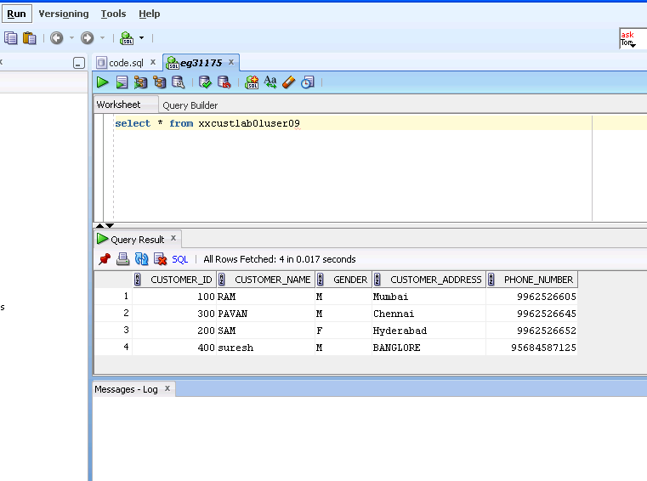

* When the table is validated from the PLSQL STORE PROCEDURE,the mobile number with more than 10 digits is not taken in the table as shown below.

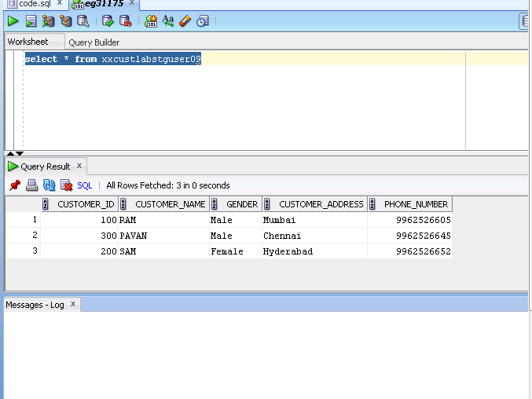

**Q.3**

**Form Personalization:**

1. **Making Document Number Field Compulsory**

* Go to Oracle Application and under your user add the responsibility “Receivables Super Vision Corporation Japan” and save it.

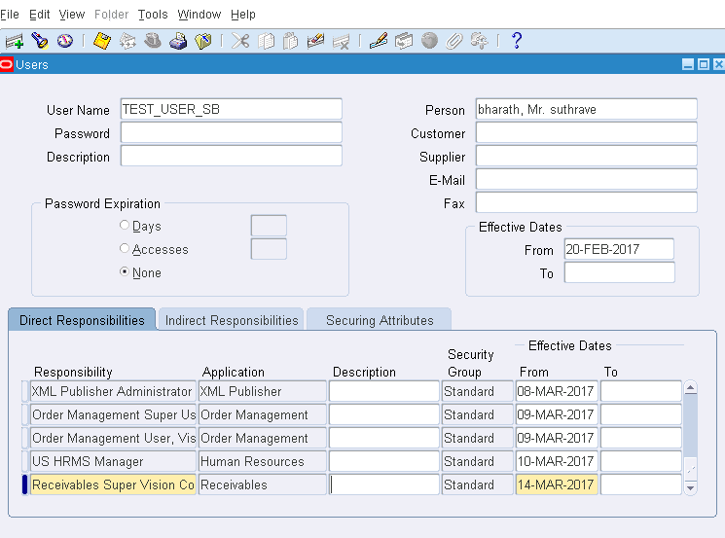

* After creating the responsibility, navigate to “transaction” and go to “transaction” sub navigation and open it.
* Here we notice that “Document Number” is not mandatory and is optional.
* We have to make is mandatory by creating a rule in the “HELP” MENU.
* Go through the Help navigation to personalize the rules.

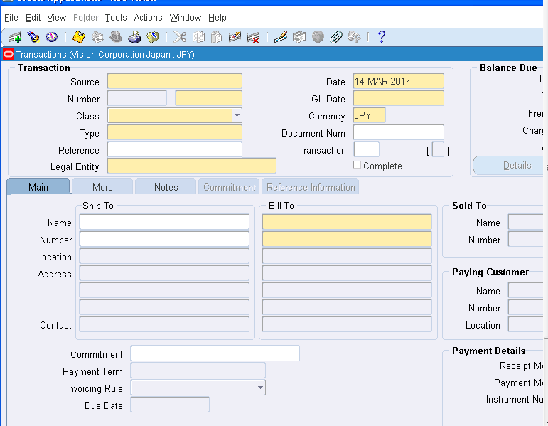

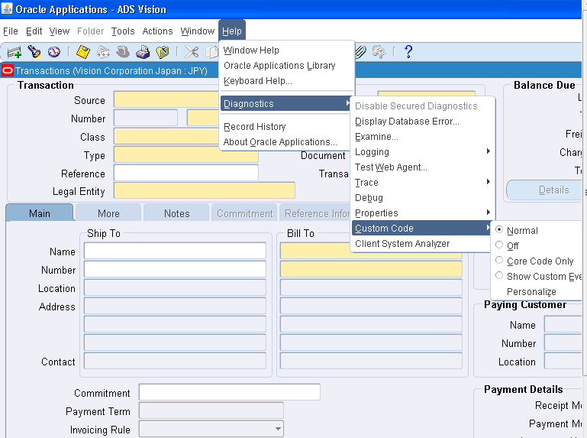

* In the personalization form, create a new rule “Document Number Compulsory “ and assign the user in the Level field in the Condition block.

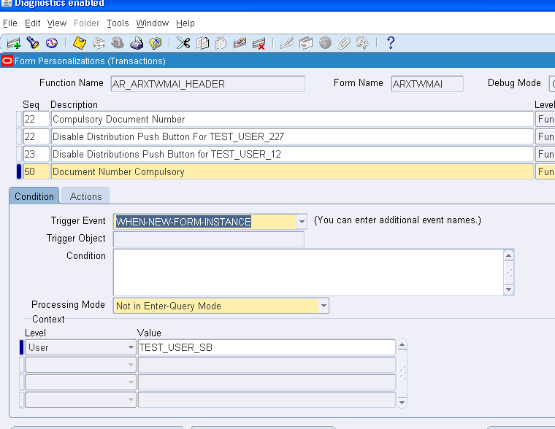

* Go to Actions Block and select the Target object “TGW_HEADER.DOC_SEQUNECE_MIR” which represents the “Document Number”field.
* Select the property name as “Required (Item Instance)” and make it “TRUE”.

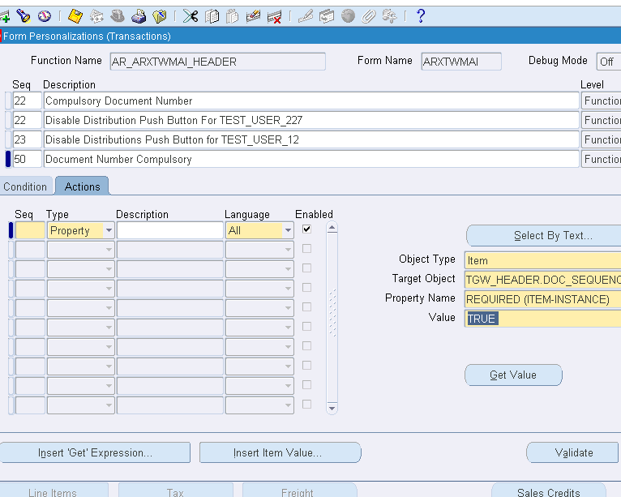

* AFTER MAKING IT TRUE,VALIDATE AND APPLY IT.
* GO TO CONDITIONS AND APPLY IT.
* NOW THE “DOCOUMENT NUMBER” IS IN “YELLOW” COLOR WHICH MEANS IT IS MANDATORY FILED.

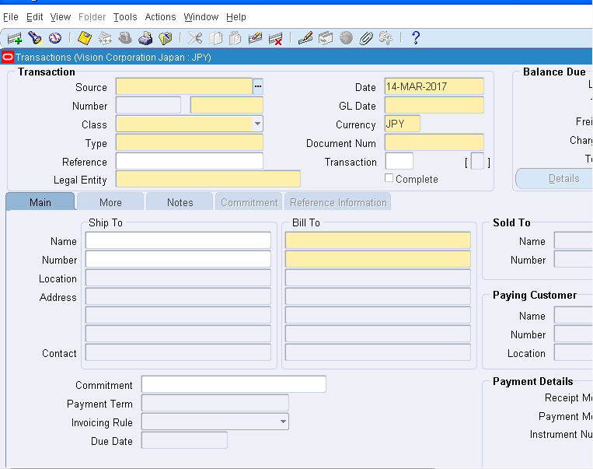

**Q.3.**

**2. Disabling the “Distributions” button**

* Go the Oracle Application and switch Responsibility to “receivable Super Vision Corporation Japan”.
* Navigate to Transaction - > Transaction.
* Here we see the Distribution Button, which we have to disable.

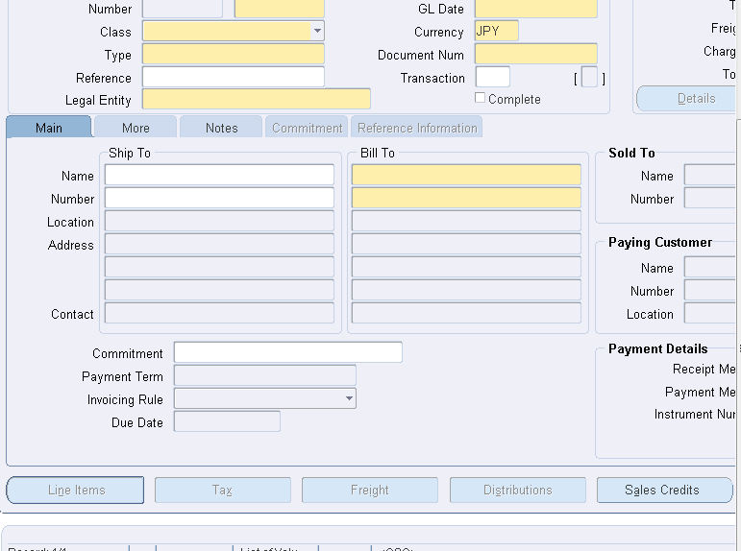

* Go to Help and personalize the rules form.
* Add a new rule “Disable Distribution button”.
* In the condition Block, assign the user to the “Level” and add the user whom can see the personalization.
* 

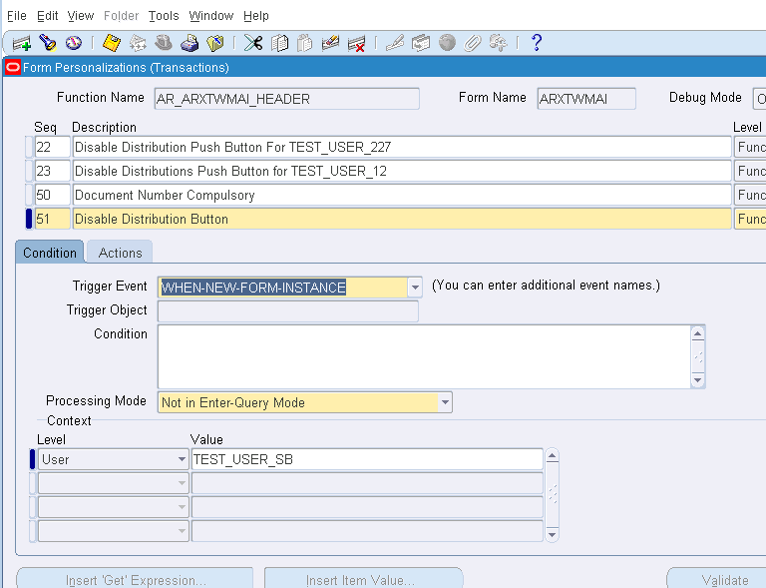

* After assigning User,Go to Actions Block.
* Assign Target Object as “TRW_HEADER.HEADER_ACCOUNTING” and
* Select Property Name = Displayed
* And Value = “FALSE”.

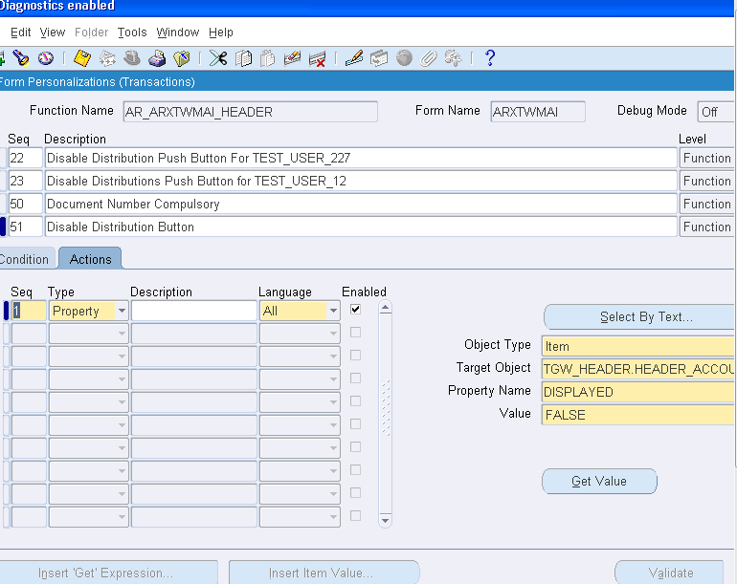

* AFTER ASSIGNING ALL THESE THINGS,VALIDATE THE RULE AND APPLY IT.
* NOW YOU CAN SEE IN THE TRANSACTION WINDOW,THE DISTRIBUTION BUTTON IS DISABLED AS SHOWN BELOW.

